Mauritius

## Freedom House political status

The data set shows the Freedom House political scores and status of the country each year.

## # A tibble: 19 x 5  
## country iso3c date mean status  
## <chr> <chr> <dbl> <dbl> <chr>   
## 1 Mauritius MUS 1996 1.5 Free   
## 2 Mauritius MUS 1998 1.5 Free   
## 3 Mauritius MUS 2000 1.5 Free   
## 4 Mauritius MUS 2002 1.5 Free   
## 5 Mauritius MUS 2003 1.5 Free   
## 6 Mauritius MUS 2004 1 Free   
## 7 Mauritius MUS 2005 1 Free   
## 8 Mauritius MUS 2006 1.5 Free   
## 9 Mauritius MUS 2007 1.5 Free   
## 10 Mauritius MUS 2008 1.5 Free   
## 11 Mauritius MUS 2009 1.5 Free   
## 12 Mauritius MUS 2010 1.5 Free   
## 13 Mauritius MUS 2011 1.5 Free   
## 14 Mauritius MUS 2012 1.5 Free   
## 15 Mauritius MUS 2013 1.5 Free   
## 16 Mauritius MUS 2014 1.5 Free   
## 17 Mauritius MUS 2015 1.5 Free   
## 18 Mauritius MUS 2016 1.5 Free   
## 19 Mauritius MUS 2017 1.5 Free

## Freedom House classification of political change

The data set shows the GDP growth and the ecomic growth classification of the country each year.

## # A tibble: 19 x 4  
## country iso3c date politicalChangeFH  
## <chr> <chr> <dbl> <chr>   
## 1 Mauritius MUS 1996 no change   
## 2 Mauritius MUS 1998 no change   
## 3 Mauritius MUS 2000 no change   
## 4 Mauritius MUS 2002 no change   
## 5 Mauritius MUS 2003 no change   
## 6 Mauritius MUS 2004 democratization   
## 7 Mauritius MUS 2005 no change   
## 8 Mauritius MUS 2006 autocratization   
## 9 Mauritius MUS 2007 no change   
## 10 Mauritius MUS 2008 no change   
## 11 Mauritius MUS 2009 no change   
## 12 Mauritius MUS 2010 no change   
## 13 Mauritius MUS 2011 no change   
## 14 Mauritius MUS 2012 no change   
## 15 Mauritius MUS 2013 no change   
## 16 Mauritius MUS 2014 no change   
## 17 Mauritius MUS 2015 no change   
## 18 Mauritius MUS 2016 no change   
## 19 Mauritius MUS 2017 no change

## Freedom House score trend

The plot shows the Freedom House scores trend of the country.

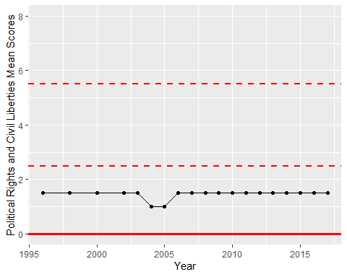

Freedom House Score Trend